**Hands on 1**

**Create a Spring Web Project using Maven**   
SpringLearnApplication.java – Main Class

package com.cognizant.spring_learn;

import org.springframework.boot.SpringApplication;

import org.springframework.boot.autoconfigure.SpringBootApplication;

@SpringBootApplication

public class SpringLearnApplication {

public static void main(String[] args) {

System.*out*.println("SpringLearnApplication started...");

SpringApplication.*run*(SpringLearnApplication.class, args);

}

}

**pom.xml**

<?xml version="1.0" encoding="UTF-8"?>

<project xmlns="http://maven.apache.org/POM/4.0.0"

xmlns:xsi="http://www.w3.org/2001/XMLSchema-instance"

xsi:schemaLocation="http://maven.apache.org/POM/4.0.0

https://maven.apache.org/xsd/maven-4.0.0.xsd">

<modelVersion>4.0.0</modelVersion>

<groupId>com.cognizant</groupId>

<artifactId>spring_learn</artifactId>

<version>0.0.1-SNAPSHOT</version>

<packaging>jar</packaging>

<name>spring_learn</name>

<description>Spring Boot Web Project</description>

<parent>

<groupId>org.springframework.boot</groupId>

<artifactId>spring-boot-starter-parent</artifactId>

<version>2.7.18</version>

<relativePath/> <!-- lookup parent from repository -->

</parent>

<properties>

<java.version>1.8</java.version>

</properties>

<dependencies>

<!-- Spring Boot Web Starter -->

<dependency>

<groupId>org.springframework.boot</groupId>

<artifactId>spring-boot-starter-web</artifactId>

</dependency>

<!-- DevTools -->

<dependency>

<groupId>org.springframework.boot</groupId>

<artifactId>spring-boot-devtools</artifactId>

<scope>runtime</scope>

<optional>true</optional>

</dependency>

<!-- Spring Boot Test -->

<dependency>

<groupId>org.springframework.boot</groupId>

<artifactId>spring-boot-starter-test</artifactId>

<scope>test</scope>

</dependency>

</dependencies>

<build>

<plugins>

<plugin>

<groupId>org.springframework.boot</groupId>

<artifactId>spring-boot-maven-plugin</artifactId>

</plugin>

</plugins>

</build>

</project>

**OUTPUT:**

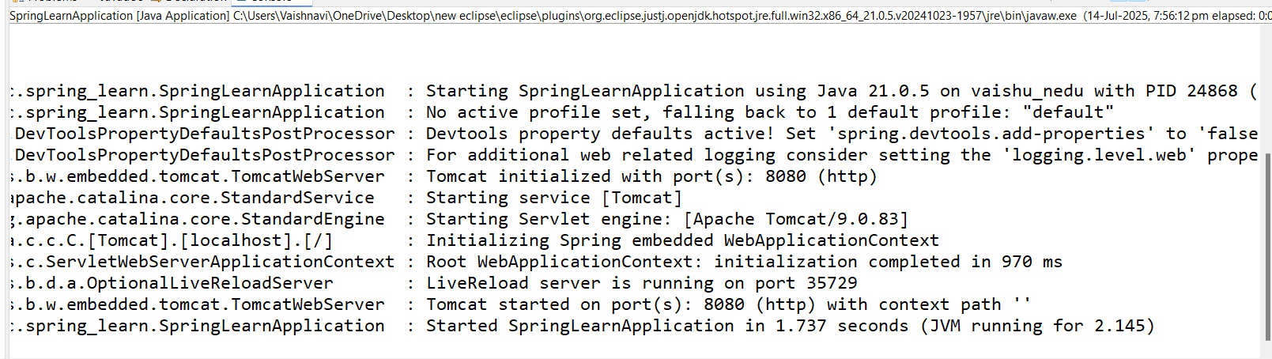

**Hands-on 4: Spring Core – Load Country from Spring Configuration XML**

An airlines website is going to support booking on four countries. There will be a drop down on the home page of this website to select the respective country. It is also important to store the two-character ISO code of each country. 

|  |  |
| --- | --- |
| **Code** | **Name** |
| US | United States |
| DE | Germany |
| IN | India |
| JP | Japan |

**country.xml**

<?xml version="1.0" encoding="UTF-8"?>

<beans xmlns="http://www.springframework.org/schema/beans"

xmlns:xsi="http://www.w3.org/2001/XMLSchema-instance"

xsi:schemaLocation="http://www.springframework.org/schema/beans

https://www.springframework.org/schema/beans/spring-beans.xsd">

<bean id="country" class="com.cognizant.spring_learn.Country">

<property name="code" value="IN" />

<property name="name" value="India" />

</bean>

</beans>

**Country.java**

package com.cognizant.spring_learn;

import org.slf4j.Logger;

import org.slf4j.LoggerFactory;

public class Country {

private String code;

private String name;

private static final Logger LOGGER = LoggerFactory.getLogger(Country.class);

public Country() {

LOGGER.debug("Inside Country Constructor.");

}

public String getCode() {

LOGGER.debug("Inside getCode()");

return code;

}

public void setCode(String code) {

LOGGER.debug("Inside setCode()");

this.code = code;

}

public String getName() {

LOGGER.debug("Inside getName()");

return name;

}

public void setName(String name) {

LOGGER.debug("Inside setName()");

this.name = name;

}

@Override

public String toString() {

return "Country [code=" + code + ", name=" + name + "]";

}

}

**SpringLearnApplication.java**

package com.cognizant.spring_learn;

import org.slf4j.Logger;

import org.slf4j.LoggerFactory;

import org.springframework.context.ApplicationContext;

import org.springframework.context.support.ClassPathXmlApplicationContext;

import com.cognizant.spring_learn.Country;

public class SpringLearnApplication {

private static final Logger *LOGGER* = LoggerFactory.*getLogger*(SpringLearnApplication.class);

public static void main(String[] args) {

*LOGGER*.info("SpringLearnApplication started...");

*displayCountry*();

}

public static void displayCountry() {

ApplicationContext context = new ClassPathXmlApplicationContext("country.xml");

Country country = context.getBean("country", Country.class);

*LOGGER*.debug("Country : {}", country.toString());

}

}

**OUTPUT:**

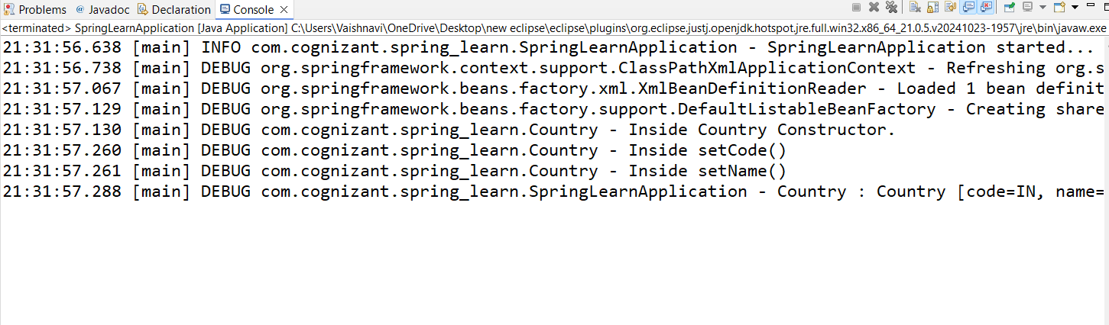

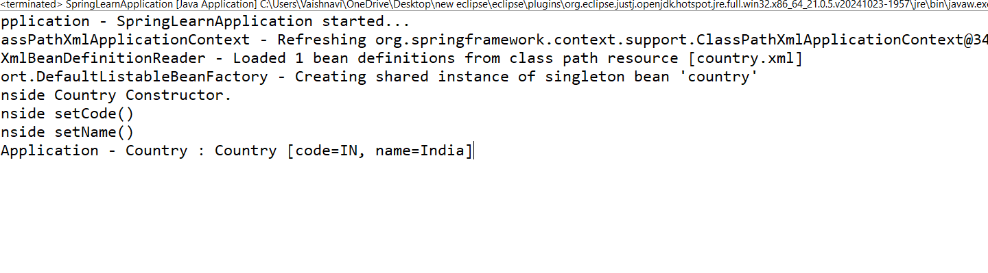

**Hello World RESTful Web Service**Write a REST service in the spring learn application created earlier, that returns the text "Hello World!!" using Spring Web Framework. Refer details below:

Method: GET  
URL: /hello  
Controller: com.cognizant.spring-learn.controller.HelloController  
Method Signature: public String sayHello()  
Method Implementation: return hard coded string "Hello World!!"  
Sample Request: http://localhost:8083/hello  
Sample Response: Hello World!! 

**Controller package:**

**HelloController.java**

package com.cognizant.spring_learn.controller;

import org.slf4j.Logger;

import org.slf4j.LoggerFactory;

import org.springframework.web.bind.annotation.GetMapping;

import org.springframework.web.bind.annotation.RestController;

@RestController

public class HelloController {

private static final Logger *LOGGER* = LoggerFactory.*getLogger*(HelloController.class);

@GetMapping("/hello")

public String sayHello() {

*LOGGER*.info("START - sayHello()");

*LOGGER*.info("END - sayHello()");

return "Hello World!!";

}

}

**application.properties**

spring.application.name=spring-learn

server.port=8083

**Run the Application:**

**Springlearnapplication.java**

package com.cognizant.spring_learn;

import org.slf4j.Logger;

import org.slf4j.LoggerFactory;

import org.springframework.boot.SpringApplication; // Add this import

import org.springframework.boot.autoconfigure.SpringBootApplication;

import org.springframework.context.ApplicationContext;

import org.springframework.context.support.ClassPathXmlApplicationContext;

@SpringBootApplication

public class SpringLearnApplication {

private static final Logger *LOGGER* = LoggerFactory.*getLogger*(SpringLearnApplication.class);

public static void main(String[] args) {

*LOGGER*.info("SpringLearnApplication started...");

SpringApplication.*run*(SpringLearnApplication.class, args); // Starts web app

*displayCountry*(); // optional: shows XML-based Country bean

}

public static void displayCountry() {

ApplicationContext context = new ClassPathXmlApplicationContext("country.xml");

Country country = context.getBean("country", Country.class);

*LOGGER*.debug("Country : {}", country.toString());

}

}

**OUTPUT:**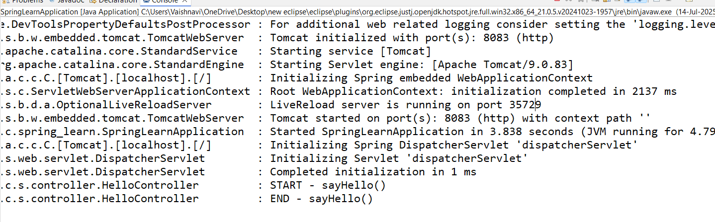

**TEST IT:**

Visit: <http://localhost:8083/hello>

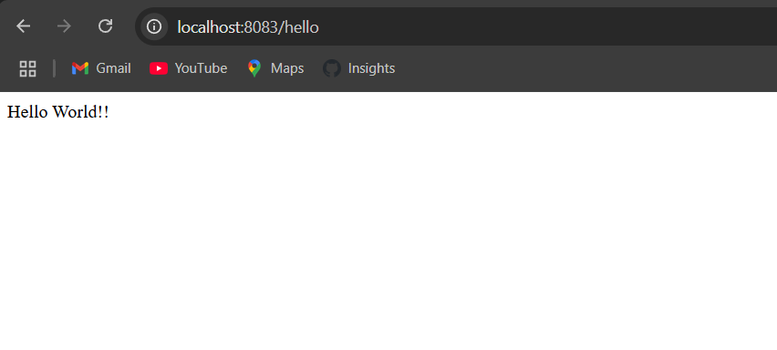

**REST - Country Web Service**   
  
Write a REST service that returns India country details in the earlier created spring learn application.  
  
**URL**: /country  
**Controller**: com.cognizant.spring-learn.controller.CountryController  
**Method Annotation**: @RequestMapping  
**Method Name**: getCountryIndia()  
**Method Implementation**: Load India bean from spring xml configuration and return  
**Sample Request**: http://localhost:8083/country  
**Sample Response**:

{

  "code": "IN",

  "name": "India"

}

**Controller Code (CountryController.java):**

package com.cognizant.spring_learn.controller;

import com.cognizant.spring_learn.Country;

import org.slf4j.Logger;

import org.slf4j.LoggerFactory;

import org.springframework.context.ApplicationContext;

import org.springframework.context.support.ClassPathXmlApplicationContext;

import org.springframework.web.bind.annotation.RequestMapping;

import org.springframework.web.bind.annotation.RestController;

@RestController

public class CountryController {

private static final Logger *LOGGER* = LoggerFactory.*getLogger*(CountryController.class);

@RequestMapping("/country")

public Country getCountryIndia() {

*LOGGER*.info("START - getCountryIndia()");

ApplicationContext context = new ClassPathXmlApplicationContext("country.xml");

Country country = context.getBean("country", Country.class);

*LOGGER*.info("END - getCountryIndia()");

return country; // Automatically converted to JSON

}

}

**country.xml Configuration:**

<beans xmlns="http://www.springframework.org/schema/beans"

xmlns:xsi="http://www.w3.org/2001/XMLSchema-instance"

xsi:schemaLocation="http://www.springframework.org/schema/beans

http://www.springframework.org/schema/beans/spring-beans.xsd">

<bean id="country" class="com.cognizant.spring_learn.Country">

<property name="code" value="IN"/>

<property name="name" value="India"/>

</bean>

</beans>

**1.What happens in the controller method?**

**->** The @RequestMapping("/country") maps HTTP GET requests to the method.

-> ApplicationContext reads country.xml and loads the country bean.

-> The bean is returned by the method.

**2.How is the bean converted into a JSON response?**

-> The @RestController annotation + Jackson library (included in Spring Boot) automatically converts Java objects to JSON.

-> So the Country bean becomes:

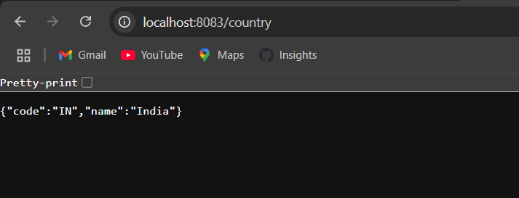

**3.Network Tab in Chrome Developer Tools:**

* Shows HTTP GET request to /country
* Response headers include:

Content-Type: application/json

Status: 200 OK

**4. Postman Headers Tab:**

* Shows HTTP headers like:
  + Content-Type: application/json
  + Content-Length
  + Date
  + Server: Apache Tomcat/9.0.83

**OUTPUT:**

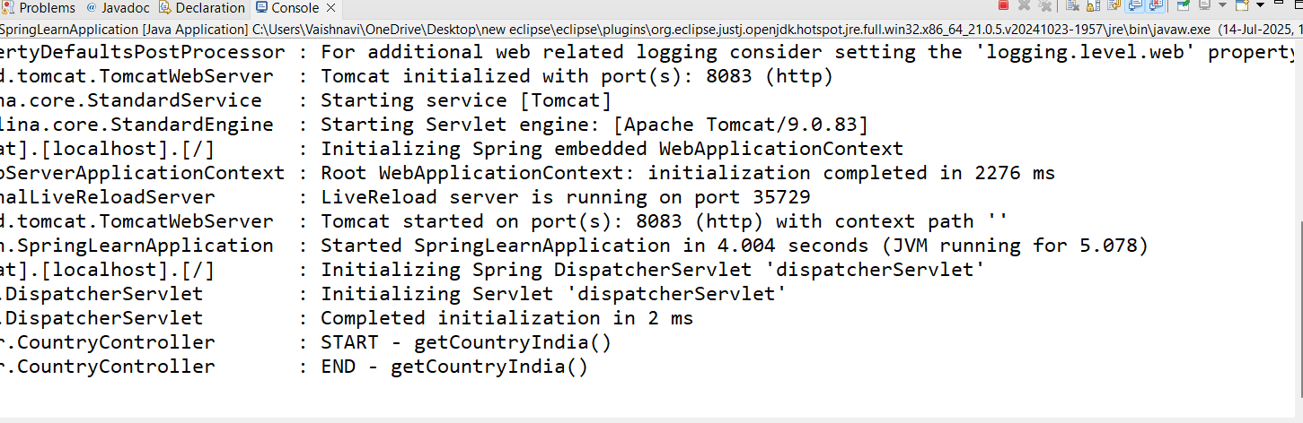

**REST - Get country based on country code**Write a REST service that returns a specific country based on country code. The country code should be case insensitive.  
  
Controller: com.cognizant.spring-learn.controller.CountryController  
Method Annotation: @GetMapping("/countries/{code}")  
Method Name: getCountry(String code)  
Method Implemetation: Invoke countryService.getCountry(code)   
Service Method: com.cognizant.spring-learn.service.CountryService.getCountry(String code)

**country.xml**

<?xml version="1.0" encoding="UTF-8"?>

<beans xmlns="http://www.springframework.org/schema/beans"

xmlns:xsi="http://www.w3.org/2001/XMLSchema-instance"

xsi:schemaLocation="http://www.springframework.org/schema/beans

http://www.springframework.org/schema/beans/spring-beans.xsd">

<bean id="country" class="com.cognizant.spring_learn.Country">

<property name="code" value="IN"/>

<property name="name" value="India"/>

</bean>

<bean id="countryList" class="java.util.ArrayList">

<constructor-arg>

<list>

<bean class="com.cognizant.spring_learn.Country">

<property name="code" value="IN"/>

<property name="name" value="India"/>

</bean>

<bean class="com.cognizant.spring_learn.Country">

<property name="code" value="US"/>

<property name="name" value="United States"/>

</bean>

<bean class="com.cognizant.spring_learn.Country">

<property name="code" value="DE"/>

<property name="name" value="Germany"/>

</bean>

<bean class="com.cognizant.spring_learn.Country">

<property name="code" value="JP"/>

<property name="name" value="Japan"/>

</bean>

</list>

</constructor-arg>

</bean>

</beans>

**Country.java**

**package** com.cognizant.spring_learn;

**import** org.slf4j.Logger;

**import** org.slf4j.LoggerFactory;

**public** **class** Country {

**private** **static** **final** Logger ***LOGGER*** = LoggerFactory.*getLogger*(Country.**class**);

**private** String code;

**private** String name;

**public** Country() {

***LOGGER***.debug("Inside Country Constructor.");

}

**public** String getCode() {

***LOGGER***.debug("Inside getCode()");

**return** code;

}

**public** **void** setCode(String code) {

***LOGGER***.debug("Inside setCode()");

**this**.code = code;

}

**public** String getName() {

***LOGGER***.debug("Inside getName()");

**return** name;

}

**public** **void** setName(String name) {

***LOGGER***.debug("Inside setName()");

**this**.name = name;

}

@Override

**public** String toString() {

**return** "Country [code=" + code + ", name=" + name + "]";

}

}

**CountryService.java**

**package** com.cognizant.spring_learn.service;

**import** java.util.List;

**import** org.springframework.beans.factory.annotation.Autowired;

**import** org.springframework.context.ApplicationContext;

**import** org.springframework.context.support.ClassPathXmlApplicationContext;

**import** org.springframework.stereotype.Service;

**import** com.cognizant.spring_learn.Country;

@Service

**public** **class** CountryService {

**public** Country getCountry(String code) {

ApplicationContext context = **new** ClassPathXmlApplicationContext("country.xml");

List<Country> countryList = context.getBean("countryList", List.**class**);

**return** countryList.stream()

.filter(c -> c.getCode().equalsIgnoreCase(code))

.findFirst()

.orElse(**null**); // Or throw custom CountryNotFoundException

}

}

**CountryController.java**

package com.cognizant.spring_learn.controller;

import org.springframework.beans.factory.annotation.Autowired;

import org.springframework.web.bind.annotation.*;

import com.cognizant.spring_learn.Country;

import com.cognizant.spring_learn.service.CountryService;

@RestController

@RequestMapping("/countries")

public class CountryController {

@Autowired

private CountryService countryService;

@GetMapping("/{code}")

public Country getCountry(@PathVariable String code) {

return countryService.getCountry(code);

}

}

**Test in Browser:**

<http://localhost:8083/country/in>

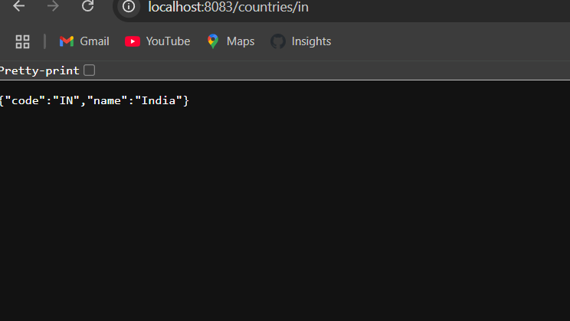

**OUTPUT:**

